Live Google Ads Campaign Report
Prepared By : Abdul Raheem F

1. Executive Summary
This report presents the planning, setup, and optimization process of a simulated Google Ads Search Campaign for FitLife Pro, an imaginary online fitness and weight loss platform. The campaign was designed to drive targeted website traffic and generate qualified leads from users actively searching for fitness solutions in India.
The project provided valuable hands-on experience in digital advertising strategy, keyword research, ad creation, and campaign optimization using the Google Ads platform.

2. Campaign Objectives
The primary objective of the campaign was to simulate a real-world Search campaign focused on Website Traffic with an underlying goal of lead generation.
Key Objectives:
- Drive relevant and qualified traffic to the FitLife Pro website
- Target users with high intent for fitness, workout plans, and weight loss solutions
- Understand search user behavior and keyword performance
- Simulate a complete digital advertising funnel for an online fitness coaching service
Justification for Choosing “Website Traffic” Objective:
- Most suitable for beginners to learn campaign mechanics
- Provides clear insights into keyword effectiveness and user intent
- Serves as a strong foundation before moving to lead generation or sales objectives

3. Campaign Strategy
A well-structured strategy was developed focusing on user intent, relevance, and performance optimization.
Campaign Details:
- Campaign Type: Search Campaign (Text Ads)
- Ad Format: Responsive Search Ads (RSA)
- Targeting:
  - Location: India
  - Language: English
  - Devices: Mobile-first targeting (with desktop inclusion)
- Audience Segments: Fitness enthusiasts, weight loss seekers, beginners looking for gym/diet plans, and individuals interested in online personal training
Keyword Strategy: High-intent keywords were carefully selected to capture users in the consideration and decision-making stages.
Primary Keywords:
- weight loss programs
- gym workout plans
- fitness coaching online
- diet plans for weight loss
- personal trainer online
Strategy Logic:
- Focused on problem-solving search queries (pain-point driven)
- Used a combination of Broad Match and Phrase Match to balance reach and relevance
- Emphasized long-tail keywords for better conversion potential
Ad Copy Strategy: Ad copies were crafted using the AIDA framework (Attention – Interest – Desire – Action):
- Attention: Strong, benefit-oriented headlines
- Interest: Highlighted personalized solutions
- Desire: Emphasized affordability and expert guidance
- Action: Clear call-to-action encouraging immediate engagement
Ad Assets/Extensions Used:
- Sitelinks (Services, Pricing, Workout Plans, About Us)
- Callouts (Free Consultation, Certified Trainers, 30-Day Challenge, Results Guaranteed)
These extensions significantly improve ad visibility, Click-Through Rate (CTR), and overall user engagement.

4. Campaign Setup
The campaign was configured professionally on the Google Ads platform with the following key steps:
- Created a new Search Campaign
- Connected the FitLife Pro website (built on Google Sites)
- Added relevant keywords manually and through Google’s keyword planner suggestions
- Developed multiple headlines and descriptions to enable Responsive Search Ads
- Set a daily budget of ₹20 (simulation purpose)
- Implemented ad extensions for enhanced performance

5. Challenges Encountered
Several practical challenges were faced during the campaign setup, reflecting real-world advertising complexities:
Technical Challenges:
- Ad descriptions exceeding character limits
- Achieving “Good” or “Excellent” ad strength
- Understanding and applying different keyword match types effectively
Platform & Approval Challenges:
- Ads entering “Under Review” status
- Delays in ad approval process
- Platform restrictions on campaign activation without payment method
Strategic Challenges:
- Selecting the most relevant and high-performing keywords
- Crafting compelling ad copy within strict character limits

6. Solutions Implemented
To overcome the above challenges, the following corrective actions were taken:
- Optimized all descriptions to stay within the 90-character limit
- Added multiple headline variations (up to 15) and descriptions to improve ad strength
- Utilized Google’s keyword suggestions and relevance tools
- Enhanced ad copy clarity, relevance, and call-to-action focus
- Added comprehensive sitelinks and callout extensions
These optimizations resulted in improved ad quality and better alignment with Google’s advertising policies.

7. Key Learnings
This simulation project offered deep practical insights into digital advertising:
Major Learnings:
- Complete structure and workflow of a Google Ads Search Campaign
- Critical importance of keyword research and match types
- Art and science of writing high-performing ad copy under constraints
- Role of ad extensions in improving visibility and CTR
- Significance of budget, bidding strategies, and campaign approval processes
Unexpected Insights:
- Even well-structured campaigns require payment verification to go live
- Ad Strength directly influences ad performance and eligibility
- The approval process plays a vital role in campaign timelines

8. Campaign Performance Analysis
The campaign generated real performance data during its run period.
Key Metrics:
• Impressions: 10,277
• Clicks: 54
• CTR (Click Through Rate): 0.53%
• Average CPC: ₹4.30
• Total Spend: ₹232
Analysis:
The campaign achieved a good number of impressions, indicating effective keyword reach and visibility. However, the CTR is relatively low, suggesting that ad copy and targeting can be improved to attract more clicks.
The cost per click is economical, showing efficient budget utilization. Most traffic was driven through mobile devices, indicating strong mobile audience engagement.

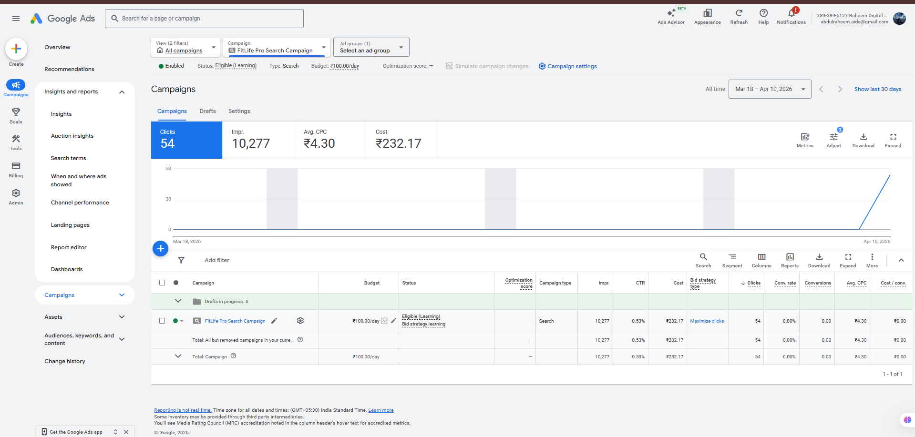
9.Performance Insights:
• Keywords like "lose weight" performed better than others
• Mobile devices contributed the majority of traffic
• Ad visibility was high, but engagement needs improvement
• Lack of strong CTA affected CTR performance

- Limitations:
• Conversion tracking was not implemented
• Landing page was basic (Google Sites)
• Limited budget restricted data collection

Recommendations for Future Campaigns
Based on the experience gained, the following improvements are recommended:
Strategic Enhancements:
- Increase daily budget for better testing and data collection
- Incorporate Exact Match keywords for higher precision targeting
- Create multiple ad groups with tightly themed keywords
- Develop at least 3–5 ad variations per ad group for A/B testing
Technical Improvements:
- Implement conversion tracking and Google Analytics integration
- Optimize the landing page for better Quality Score and user experience
- Monitor and improve Ad Relevance and Landing Page Experience scores

Growth Strategies:
- Expand keyword list with long-tail variations
- Plan for Display and Remarketing campaigns in future phases
- Conduct competitor ad analysis for benchmarking

Conclusion
The FitLife Pro Google Ads campaign simulation successfully demonstrated the end-to-end process of planning, structuring, and optimizing a professional Search advertising campaign. Although the campaign remained in simulation mode, it provided excellent practical exposure to digital marketing tools, strategies, and real-world constraints.
This internship project has significantly enhanced my understanding of Google Ads and equipped me with foundational skills necessary for executing live digital advertising campaigns in a professional environment.

